3rd Regional Heatwave Meeting
September 13, 2023

Heatwave Preparedness and Readiness:
Urban Heatwaves Actions across the Asia Pacific Region

Heatwaves account for some of the deadliest disasters on record. The dangers posed by extreme heat are growing at an alarming rate due to climate change. The impacts of extreme heat are hugely unequal in both social and geographic terms. In a heatwave, the most vulnerable and marginalized people, including casual labourers, agricultural workers, and migrants, are pushed to the front lines. The elderly, children, and pregnant and breastfeeding women are at higher risk of illness and death associated with high ambient temperatures.

The occurrence of extreme-heat events is unprecedented in the observed record and will grow with increasing global warming, according to the Sixth Assessment report from the Intergovernmental Panel on Climate Change (IPCC). Every increment of warming matters, and the projected increases are greatest for the rarest and most extreme events.

There is compelling evidence that the world’s lowest-income countries — those least responsible for climate change — are already experiencing disproportionate increases in extreme heat. The combined effects of warming, ageing and urbanization will cause a significant increase in the number of at-risk people in developing countries in the coming decades. Projected future death rates from extreme heat are staggeringly high — comparable in magnitude by the end of the century to all cancers or all infectious diseases — and staggeringly unequal, with people in poorer countries seeing far greater levels of increase.

Cities are at the epicentre of vulnerability to heatwaves. Informal and off-grid settlements, which share many characteristics with camps in humanitarian settings, are at particularly high risk. Analysts project a 700 per cent global increase in the number of urban poor people living in extreme-heat conditions by the 2050s.4 The largest increases are expected in West Africa and South-East Asia.

To prevent a future of recurrent heat disasters, aggressive steps are needed now. The single most important arena for action is in slowing and stopping climate change. Limiting global warming to 1.5°C rather than 2°C could result in up to 420 million fewer people being frequently exposed to extreme heatwaves and around 65 million fewer people being frequently exposed to ‘exceptional’ heatwaves.6 Large and targeted investments in adapting to extreme heat and protecting the most vulnerable people should also be an urgent priority. At present, efforts on these fronts are woefully insufficient to avoid massive future loss and damage from extreme heat.

EL NINO and HEATWAVE OUTLOOK FOR ASIA PACIFIC
Madhab Uprety
Climate Centre

During El Nino, the trade winds weaken, and the warm surface water shifts back towards the Central Pacific pulling moisture away from the Western Pacific. Convection migrates away towards central tropical Pacific (increased rainfall in Kiribati, Peru etc.). Under neutral conditions, the easterly trade winds across the surface of the tropical Pacific Ocean, brings warm moist air and warmer surface waters towards the western Pacific and keeping the central Pacific Ocean relatively cool. This is what produces a generally warm wet climate in Western Pacific, SE Asia and the maritime continent. During La Niña, the trade winds strengthen driving more warm water towards the Western Pacific. Central and eastern tropical Pacific becomes cooler than usual. Resulting more convection and cloudiness over North of Australia producing warmer and wetter conditions in Western Pacific, SE Asia.

El Nino Forecast for 2023
As of mid-August 2023, the previously moderate El Niño conditions in the central-eastern equatorial Pacific have strengthened further. Almost all of the models forecast an El Niño event during Northern Hemisphere autumn continuing into winter (with greater than 95% chance) and early spring of 2024. Given recent developments, forecasters are more confident in a "strong" El Niño event, roughly 2 in 3 odds of an event reaching or exceeding 1.5°C for the November-January seasonal average in Niño-3.4. However, note that a strong El Niño does not necessarily equate to strong El Niño impacts locally.

El Nino 2015-2016 Impact
Some notable Impact of El Nino 2015-2016 include record-breaking warm conditions for many of the tropical and sub-tropical countries. In Southeast Asia, these included drought affecting large parts of the Mekong river basin region (Vietnam, Cambodia, Myanmar). Also in the Philippines, 85 per cent of provinces were affected in terms of water availability and loss of crops. There was also longer dry seasons in Indonesia. In South Asia, large parts of India suffered a severe and prolonged drought as a combined effect of hot and dry weather. In North Pacific, Marshall Islands, Micronesia, and Palau all declared states of emergency regarding water availability. Significant agricultural losses were also reported. In Central Pacific, drought conditions persisted in Kiribati and Tuvalu – even until early 2017. Tonga also faced similar dry conditions. Central and South Pacific faced elevated tropical storm (or cyclone) risks due to a shift in the tracking of storms. Cyclone Pam in Tuvalu, Vanuatu, Solomon Islands Cyclone Winston in Fiji. PNG was also affected with persistent drought.

Heatwave in Asia during April-May-June 2023
- Temperatures climbed to highs of 45 degrees Celsius in Myanmar, 44.5 degrees Celsius in India and 41.9 degrees Celsius in China, with Thailand and Laos breaking all-time high records.
- In Vietnam, where extreme heat since April has caused record highs (up to 44.2 degrees in May),
- Pakistan recorded temperatures of 49 degrees Celsius

June-July-August season for 2023 was the warmest on record globally by a large margin. It is very likely that 2024 is going to be an even warmer year because we are going to be starting off with that El Niño event.

Summary
- In the present warming world, the risk (intensity & frequency) of extreme temperature are already very high (This year, we already witnessed the hottest summer on record)
- El Nino coupled with excess warming from climate change is going to make situation even worse (record breaking high temperatures across the globe) – 2023 summer is already the hottest summer on record
- Most parts of the Asia already witnessed record breaking temperatures this summer
- For next several months, there in enhanced probability of hotter than average temperature in almost all parts of Asia and the Pacific.
- The year 2024 could be even hotter than 2023, as we are going to start off with the El Nino event (which will peak towards the end of this year)
- We all need to prepare for the projected continued increases in heat extremes in the region (for the rest of the year , but more importantly the 2024 heat season)

HEALTH, AIR POLLUTION and HEATWAVES
Devin O’Donnell
Climate Centre

When we talk about heat, we often talk about it in the context of urban environments. This usually has something to do with what is called as Island Heat Effect. Cities and urban centers tend to have higher temperatures because of the built environment around them – the concrete buildings and infrastructure, etc. These absorb heat and that leads to higher temperatures. This can be reduced by establishing green and blue spaces. It is also important to highlight that in areas were there are higher temperatures, this coincides with other forms of inequity – areas of low-income residents, other forms of environmental pollution and waste segregation. When mitigating high temperatures in cities, it is also equally important to address other coinciding risks.

By the year 2050, nine Asian cities are expected to have an increase in average monthly temperature between one to above six degrees Celsius. This is a very significant increase that we want to pay attention to and that we should respond appropriately to as well. What are some of the impacts of heat to people living in cities. A graphic illustration from the World Health Organization summarizes the health impacts of heat, see below.

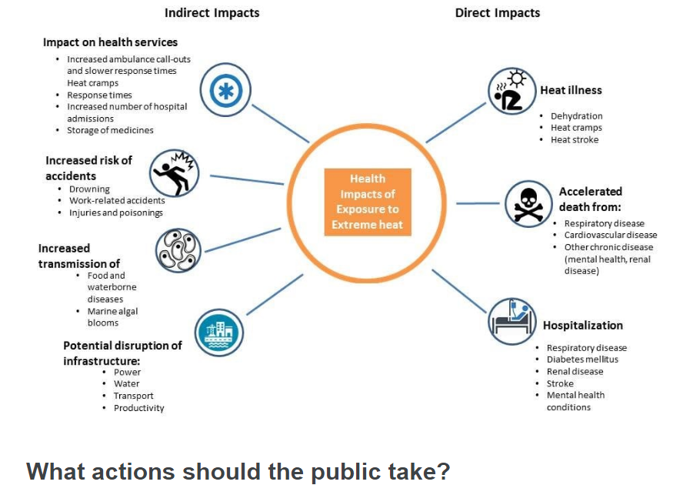
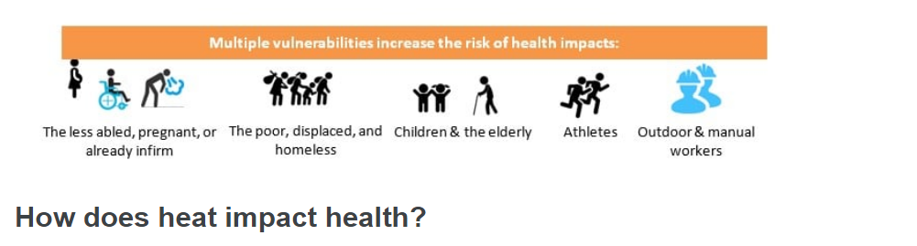
There are different forms of heat illnesses ranging from dehydration all the way to heatstroke. The biggest impact of heatwaves to humans is the increase in mortality rate that is often tied to respiratory and cardiovascular diseases. There is also an increase in the rate of hospitalization due to various conditions which leads to a higher burden to the health services. There is an increased need for emergency services that can lead to longer waiting time for admissions and access to emergency rooms. There can also be increased risk of accidents like drowning due to people seeking out water sources as a way of cooling down their body temperatures. There can also be work related accidents as shown in a recent study in the United States where there tends to be a higher risk of homicide and interpersonal violence during heatwaves. Aside from these, there is also an increase in water borne diseases and water contamination due to algal blooms.

The illustration above also shows that the elderly population are the most vulnerable during heatwaves. This is mainly due to the fact they elderly people have a lower ability to thermoregulate and because of some underlying conditions that increases the risk of having an adverse health outcome to heat exposure. There is also a study that shows social isolation as a component in terms of having higher mortality rates during heatwaves – which is usually more common among the elderly population. This is something to consider in preparing heat action plans.

Heat, when combined with other environmental exposure can lead to even worse health outcomes. This research which was undertaken in European cities but can also be applied to other cities as well, found out that there is an increase in the mortality rate when high temperatures coincide with high air pollution levels. In the Asian context, this is an important intersection due to the risks from both heat and air pollution.

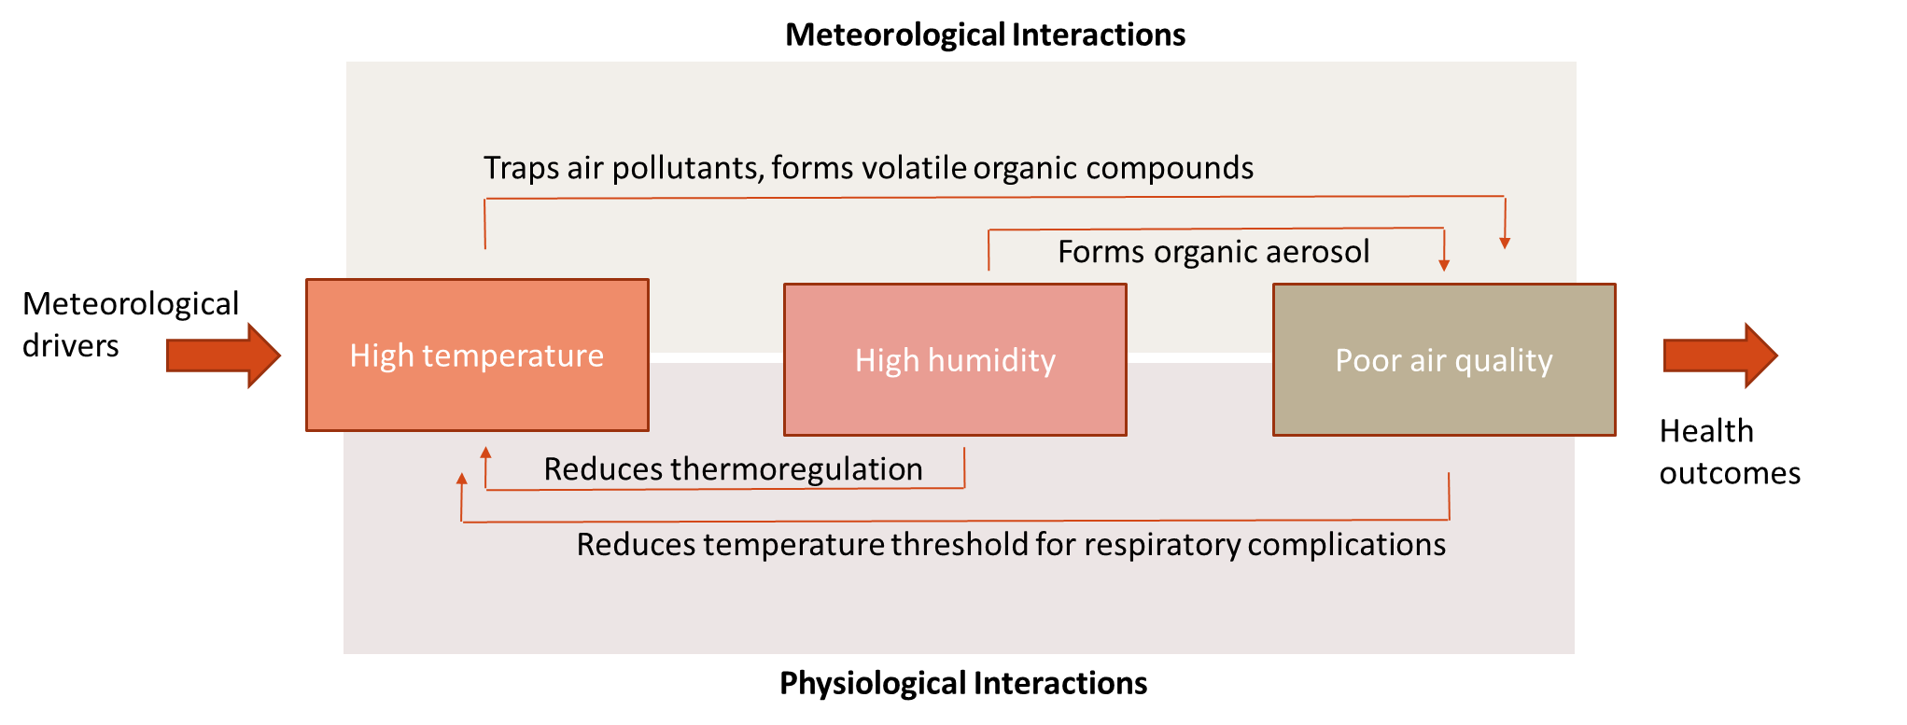

Impacts of compound exposure on health

The research conducted looked into the compound risk of all three variables – heat, humidity and air pollution. The findings showed additive effects on cardiovascular conditions, respiratory conditions, maternal and neonatal health, and over all mortality. Birth outcomes, hospitalization rates and kidney diseases are important areas of focus as well.

Challenges in reducing heat-related deaths

- lack of perceived risk when it comes to heat
- attention and funding mechanisms to support heat actions

“We cannot just talk about awareness. We also need to follow through with actions.”

GENDER DIMENSIONS of HEATWAVE PREPAREDNESS and READINESS
Mary Christine Picard
UNDRR

Gender differences in heatwave impacts are due to:
- Separate economic and social gender roles of women and men, (where they work, what money they have), including women’s unpaid care roles for children and older persons, and more women in the informal sector
- The fact that, on average, women live longer than men and are therefore a higher proportion of older persons who are worse affected by heat stress
- Biological differences related to women’s sexual and reproductive health, including impacts of heat stress on pregnant and nursing mothers
- Increased gender-based violence
- Some evidence that in Asia more women die in heatwaves (complex mix of above factors)

Inter-sectional risks in heatwaves
- Women living in poverty, especially in urban areas which become heat traps, where a lack of access to good quality housing, electricity and water supply exacerbate health impacts of heatwaves and limit coping capacity

- Women with disabilities, especially if they do not have access to refuge from the heat, and do not receive sufficient warning to prepare and additional support to initiate coping strategies

- Women already in displacement or conflict situations, in populations on the move, including refugees and IDPs, who may not receive warnings in and have reduced access to their normal coping mechanisms

Key Issues on gender and preparedness – “nothing without us”
As with all disaster preparedness, ensure women in all their diversity and people of diverse genders are:
- At the table for risk assessments and planning
- Enabled to participate meaningfully through accessible meeting formats and times
- Recognized as current leaders
- Supported to take on leadership roles through access to education, training and positive measures such as minimum quotas on community and government committees

Key actions on gender and heatwave readiness
- Specific training and information for women in communities on how to avoid or mitigate heat stress for themselves and those in their care (eg persons with severe disabilities, frail older persons, children)
- Additional resources to allow women living in poverty or on the move to initiate and access effective coping strategies

From a DRR perspective, addressing the drivers of risk for women in heatwaves needs to be part of long-term risk reduction strategies.

Localized gender assessments for heatwave risk are a key tool to identify gender related risks, for example, looking at women’s access to:
- City and local risk and impact assessments and planning processes
- Warnings and information on coping strategies
- Resources to create shelter from heat at home and in outdoor work, especially in the informal sector
- Energy/water/means of cooling and/or creating safe refuges from heat including green areas in cities.
- Access to finance for women-led MSEs and home-based workers to improve conditions

The key is empowering women as agents of change!

URBAN COLLABORATION on HEATWAVE PREPAREDNESS and READINESS
M.A. Halim
Bangladesh Red Crescent Society

Context
Bangladesh is one of the countries prone to extreme climate events. Is the seventh climate risk country in the world.
- Bangladesh is one of the countries prone to extreme climate events (7th)
- Bangladesh, under extreme heat hazard is classified as “high” (Think Hazard)
- Dhaka city is warmer than rural areas because of human activity (material used for roads, building, roofing, absorption of more solar radiation than natural land surfaces, population density, high rise infrastructures, etc.)
- Bangladesh experienced extreme heatwave in 2023

Risk Factors and Vulnerabilities
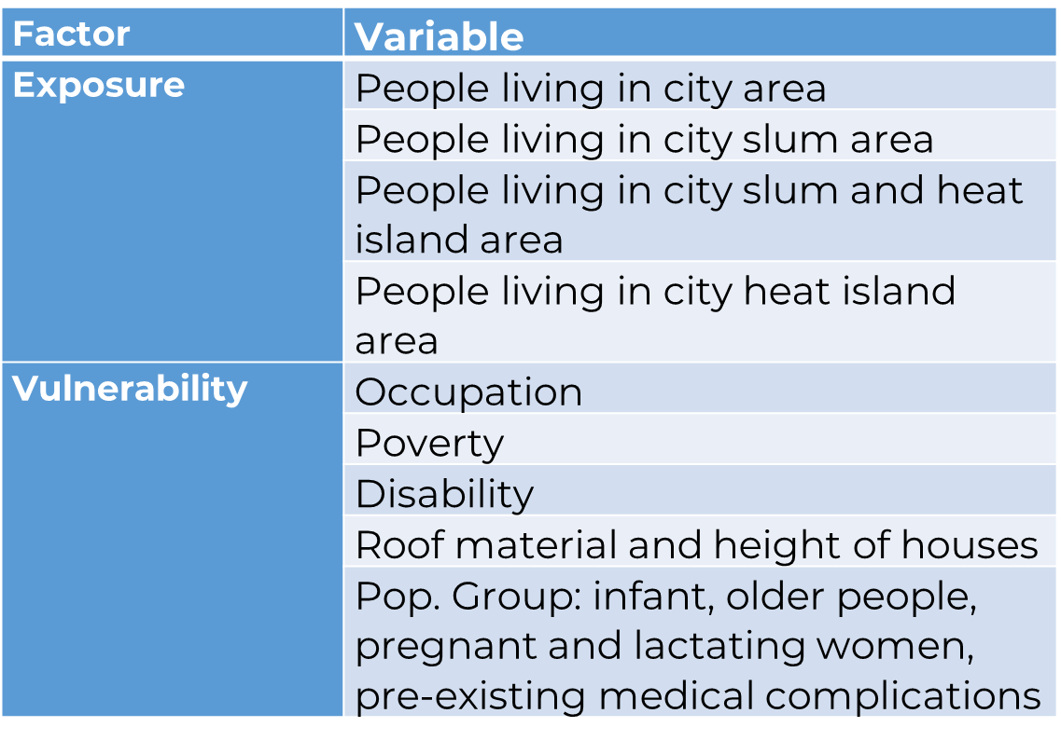

Heatwave/stress: Impact on vulnerable population (Study Findings)
- Health impact: People reported skin disease, fever, cold, heat stroke, fatigue, water borne diseases (diarrhea, cholera etc.), dehydration, respiratory problems
- Increase of health expenditure: Health expenditure increases due to increased events of disease. Around 82.81% respondents said that their healthcare expenses have increased on and average of 535 BDT
- Impact on working hour and income/livelihood: Rickshaw/van puller group are forced to skip working between 12:00pm to 3:00pm due to excessive heat outside. Around 3 Hours of working hours are lost.
- Loss of work-days: During the extreme heat months, people fell sick and couldn't go for work for about 3.27 days per month on an average.
- Impact on students: Lack of concentration and heat exhaustion
- Pressure on city water and electricity supply (caused frequent load shading)
- Rise in temperature: Around 86.56% of the respondents (n=320) said that they feel hotter than the previous years. But 84.06 % of the respondents have no idea about what the term ‘heat wave’ refers to.
- Trigger other hazards: Houses (because of the type of materials used), particularly in slums are vulnerable to increased fire incidences.

Heatwave: BDRCS Initiatives
- Collaboration with City Corporations and other Stakeholders like ICDD,B, BRAC
- Advocacy with Government
- Feasibility Study in Dhaka and Rajshahi City
- Developed Early Action protocol
- Training for volunteers and staff
- Monitoring Forecast
- Consultation workshop with stakeholders
- National workshop on Heatwave
- Trigger validation workshop with Bangladesh Meteorological Dept.
- Emergency Response with unconditional cash grant support

Partnership and Collaboration with Stakeholders
- MoU with BMD and FFWC to receive timely forecast
- Partnership with City Corporations
- Leadership (BDRCS) and collaboration between PNSs (GRC, SRC and AmCross)
- FbA-DREF: BDRCS, IFRC, GRC
- Partnership/Collaboration with WFP, CARE, Start Fund and ICDDR,B
- FbF Technical Working Group
- Advocacy with GoB on Heatwave issue

Key lessons from the Heatwave EA test
- Coordination with different stakeholders went well
- Awareness generation was effective with the combination of miking/public announcement and awareness campaigns
- Lead-time: it’s always a day less - one day is gone by time we receive the forecast.
- Lack of localized weather station: Between HI and non-HI areas, there is a differences temperature of 2ºC and heat index of upto 5 (our study). We were not able to test this. (Limitation)
- Speed in money transfer: the current mechanism and turnaround time is not good enough for anticipatory action (Challenge)
- High mobility of urban population, especially the most vulnerable groups of people, shift to another location, not available at home during the day

Ways Forward
- Capacity building of staffs and volunteers
- Engagement with more stakeholders
- Increasing awareness on heatwave among GoB and non-government stakeholders
- Implementing Anticipatory Actions once EAP is activated
- Incorporate heatwave component in relevant programme/projects
- Integrate in strategy and policy in Urban DRM
- Advocacy for development of national Heatwave EAP
- Scaling up

Practical ways to ensure inclusive heat action planning?
(extracted from the online discussion via Menti)

- Engage with marginalised communities
- Area and context specific early actions
- Undertake gender situational analysis
- Community Engagement
- Collect and analyze local climate data to have responsive plans
- Identify the adaptation practices and options for reducing heatwave health impacts
- Using SADD during assessments
- Ensure multi-level and multi-sectoral engagements of stakeholders
- Qualitative research – identify and ask the different key groups about their needs and experiences
- Raise awareness [of] different groups about heatwaves and how [they] can [respond] to this
- Create a climate justice plan focused on vulnerable groups
- Make surveys
- Awareness raising though media

